ST GABRIEL’S HIGH SCHOOL

TRANSITION BOOKLET
Name

Current School

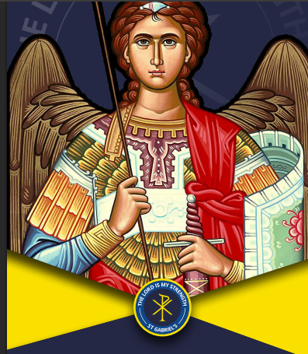

Introduction

We are really looking forward to getting to know you and to help you to reach your potential and the life goals you have now and the ones you will develop. You will grow academically and spiritually in your time with us in a really friendly community. St Gabriel’s is a school where you will make even more lifelong friends.

We know that moving from primary to secondary school is an exciting, but sometimes scary time! A new building, new rules, new teachers, new routines and new friends are just some of the changes you will experience. So, this booklet will help you get used to some of the routines and features of our school! Again, we are so excited that you are starting with us in September.

Our Mission Statement
St Gabriel’s has a strong Mission Statement which runs through all aspects of our school life. This means students appreciate, value and actively participate in the Catholic Life and mission of the school. We strive to give everyone in our school the opportunity to witness the teaching of Jesus
Mission Statement: Can you fill in the missing gaps?
At St Gabriel’s, we are an inclusive Catholic f________ who embrace diverse identities, faiths and beliefs. We strive to use our God-given talents to serve others and to succeed. The L______ is our strength, which inspires us to make p_________ contributions to our school community and be valued members of our g___________ society.

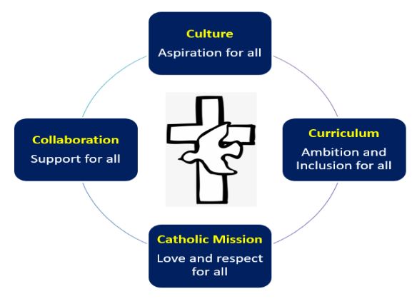

All About Me

We are going to really look after you. You are made in the image and likeness of God and we want to get to know YOU!

Preferred Name
Age
Family Members
Pets
Hobbies
Places I enjoy being most
Friends coming to St Gabriels
Favourite Subject(s)
Favourite Book
Dream Job
Best Place Visited

More About Me

- What am I good at?

- What would my family/friends say I am good at?

- What am I most proud of?

- What do I need to do to improve or make better progress?

- What leadership opportunities have you had?

- What would I like to achieve at St Gabriels?

- What are my aims for Year 7?

My Learning Journey

Life is a journey! Think back through primary school and write down your favourite memories or events that have shaped you to become the amazing person you are!



What Do I Need to Know?

Can you use the school website to help you find the answers to some of the questions below?

www.stgabrielshigh.stoccat.org.uk

What is the school address (Lower Site) and the phone number?
What is the name of the Headteacher?
What time does school start?

What time does school end?

How will you get to school?

How long will it take you to get to
school?
What subjects will you study?

What activities can you take part in as part of the enrichment
programme?

Our School Uniform
One of the different things about moving to secondary school is the change in what you will wear. At St Gabriel’s, we pride ourselves in looking smart and professional at all times.

Only available from uniform suppliers | Also available from other high street retailers
- Navy blazer with school logo.  - Year group coloured tie.  - Navy pinafore with school logo (must be at least knee length).  - Navy skort (must be at least knee length).  - Navy V-neck jumper with school logo (optional). | - Plain white closed neck shirt.  - Black tailored trousers.  - Black tailored shorts.  - Plain black, white or navy socks (below the knee or ankle) or opaque black or navy tights.  - Plain black polishable school shoes.  - Plain navy pinafore without school logo (optional)  - Plain white or cream apron.  - Navy V-neck jumper without school logo (optional).  - Navy or black outdoor coat (optional).

Why do you think wearing the correct school uniform is important?

Getting to School Safely and on Time

Getting to St Gabriel’s safely is just as important as being there. In the box below, draw the route you are going to take to school (whether that’s walking, cycling, driving or by bus). Identify spots where there could be hazards (e.g. busy roads) and explain how you will manage this safely!

Subjects I Will Study at St Gabriel’s

Find the subjects below in the word search – they are vertical, horizontal, backwards and diagonal!

S | E | R | H | N | K | D | R | Y | I | O | P | E | S | X | Z | N | D
O | L | E | N | G | L | I | S | H | T | Y | E | N | X | B | T | V | E
Q | V | B | E | R | I | L | F | V | W | X | R | J | I | R | K | L | S
T | G | N | X | R | W | U | I | H | D | F | S | O | A | P | J | W | I
R | D | A | N | C | E | T | O | E | Z | C | O | F | N | R | U | N | G
H | U | K | O | Y | Y | Y | L | H | W | E | N | E | B | Q | J | R | N
J | Y | W | M | P | E | U | F | U | M | M | A | T | H | S | T | R | T
B | E | F | Z | J | Q | H | G | O | Y | H | L | H | R | U | A | N | E
H | O | N | W | C | W | A | R | H | O | T | D | X | Q | A | R | J | C
C | L | U | H | E | D | M | P | P | I | U | E | B | M | I | Q | I | H
N | N | O | I | W | B | A | Q | W | N | V | V | R | N | K | D | S | N
E | X | P | S | R | R | R | X | O | X | S | E | W | Q | F | P | Z | O
R | D | I | T | G | M | D | I | F | A | G | L | J | P | E | S | O | L
F | I | P | O | I | V | G | Y | X | S | U | O | I | O | Y | H | L | O
S | H | E | R | O | I | X | O | S | T | M | P | E | H | X | E | W | G
L | G | W | Y | L | C | W | I | C | T | T | M | W | C | N | F | Y | Y
X | E | G | E | W | S | S | J | E | C | N | E | I | C | S | V | H | Z
Q | X | R | D | Q | L | A | Z | Q | G | O | N | N | Z | P | P | I | E
A | M | U | S | I | C | T | F | O | O | D | T | E | C | H | S | D | G

English | Art
Maths | Drama
Science | Music
History | Spanish
Geography | PE
Religion | Food Tech
French | Design Technology
PSHE | ICT
Personal Development | Challenge: Can you work out which subject has been missed in the word search?

Your Timetable
Unlike primary school you will have a two-week timetable which requires you to move around the school site calmly and quickly. We also have different lesson lengths on certain days of the week.

 | MON/TUES/THURS/FRI | WEDNESDAY
Reg/Daily checks/Assembly/Form Time programme | 8:40 – 9:10 | 8:40 – 9:35 (Personal Development)
L 1 | 9:10 – 10:10 | 9:35 – 10:30
L2 | 10:10 – 11:10 | 10:30 – 11:25
BREAK | 11:10 – 11:30 | 11:25 – 11:45
L 3 | 11:30 – 12:30 | 11:45 – 12:40
L 4 | 12:30 – 13:30 | 12:40 – 13:35
LUNCH | 13:30 – 14:10 | 13:35 – 14:15
L 5 | 14:10 – 15:10 | 14:15 – 15:10
L 6 Study Support/Enrichment & Extra Curricular activities | 15:10 – 16:00 | 15:10 – 16:00

Below is an example of what your school timetable may look like. Using the timetable and the information above, have a look through and see if you can answer the questions underneath.
Week 1 – A Period

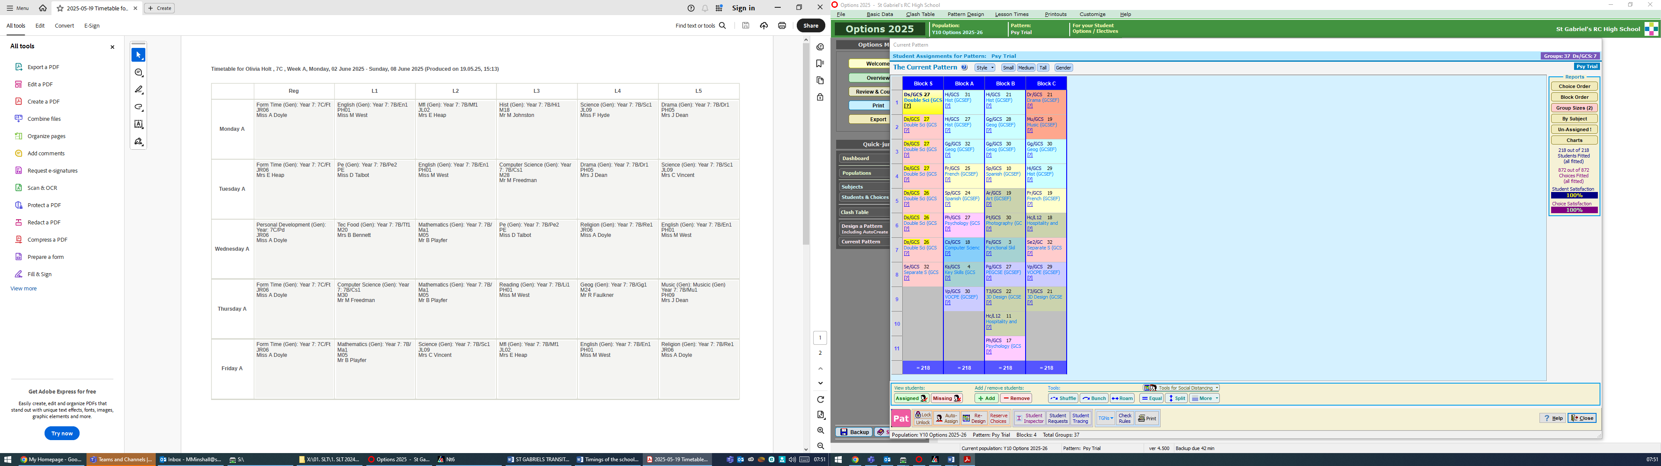
Subject

Class code

Week 2 – B
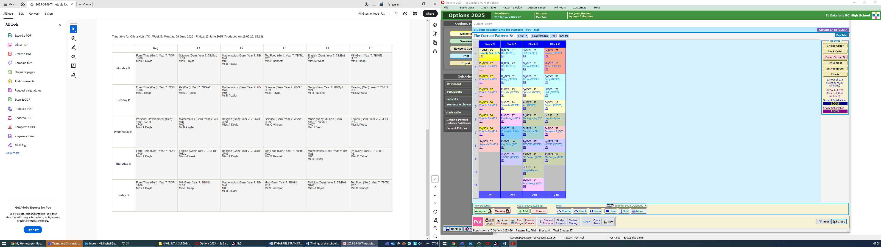

Teacher

Room

Subject Key

Reg | Registration | Ma | Maths | En | English | Te | Techology
Ar | Art | Pe | PE | Dr | Drama | Hi | History
Sc | Science | Mu | Music | Gg | Geography | Dl | Digital Literacy
RE | Religion | Fr | French | Cs | Computer Science

Questions

Imagine that this is your real timetable. Can you answer the questions below?

- What lesson do you have Period 5 on a Thursday 1- A?...........................
- What is the name of the staff who teaches you period 5 on a Friday Week 1 - B?................................
- What are the name of your Music teacher?..................................
- How long is Reg/Form time on a Monday and Wednesday? ……………………
- How long is lunch and break combined?............................................
- Which room is PE in? ……………………………………………………………..
- How many times a week do you have the following: Is there any difference on Week 1 or Week 2?
  - Maths: ………………………………..
  - English: ……………………………….
  - History: ……………………………….
- Which days will you need your PE kit
………………………………………………………………………………
- Which would be your favourite day and why?........................................

Getting Around the School Building

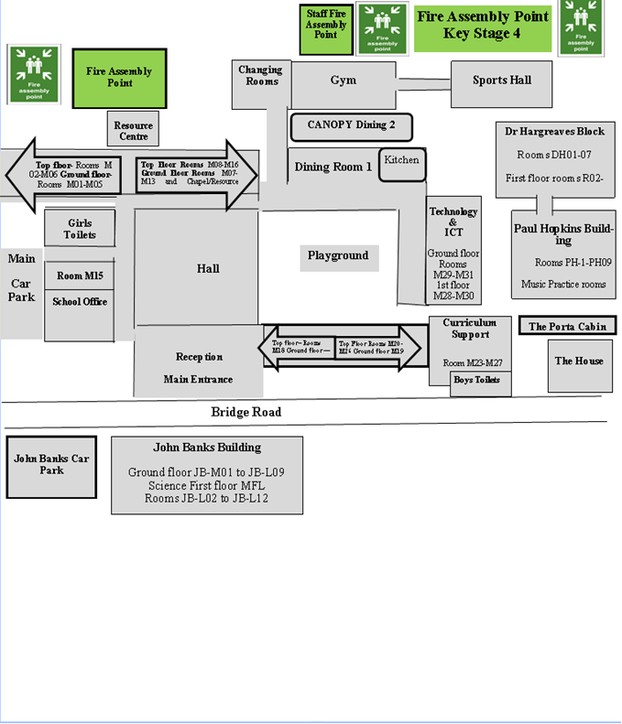

Our older students LOVE helping new students if they don’t know where they are going, so just stop and ask someone for help if you are unsure.
Images of The School Building

Front Enterance and Reception



This is the Main Front Entrance which you access at the bottom of Bridge Road.

The Chapel

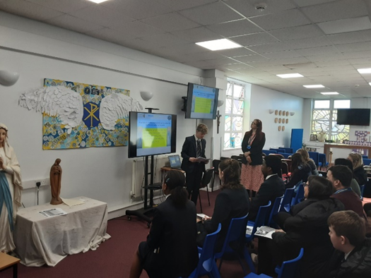

This is our Chapel where you will have Prayer and Liturgies and Sacrament of the Eucharist.

The School Hall

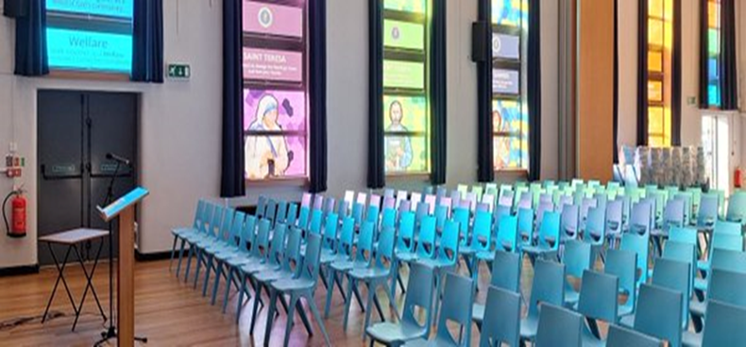

This is the main school Hall where you will have your school assemblies.

The Learning Resource Centre

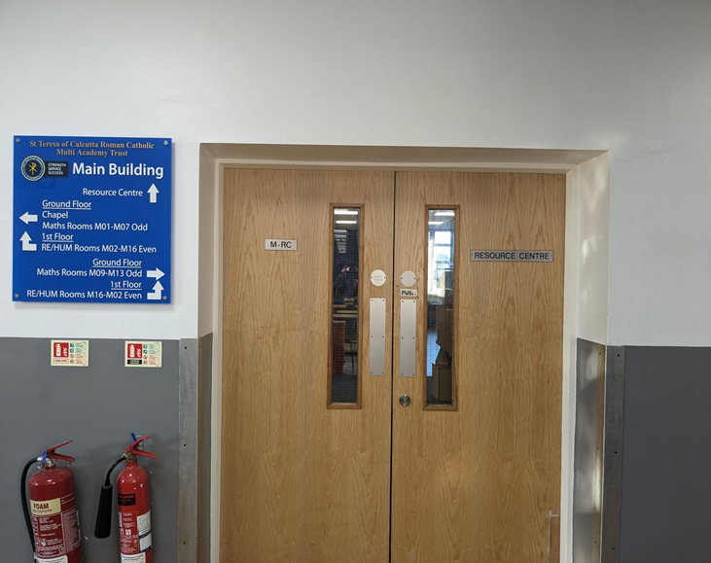

This is our Learning Resource Centre (Library) which is well stocked with lots of great books to read.

The Year 7 John Banks Building

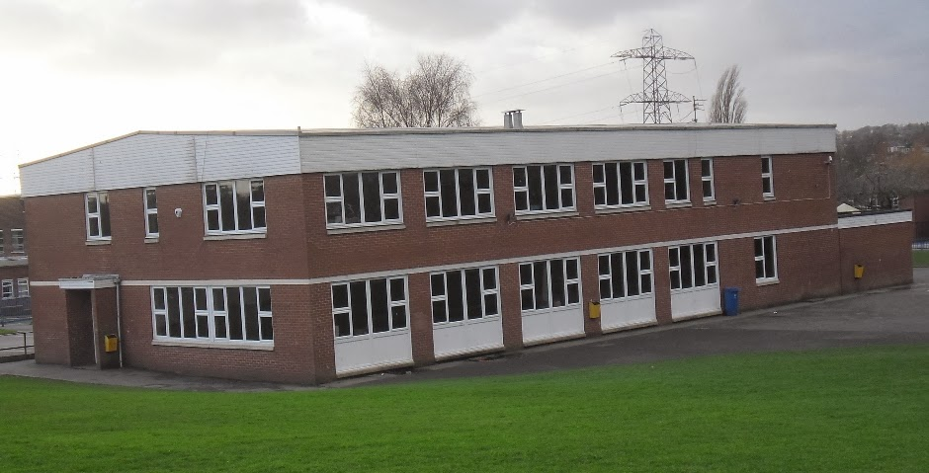

This is the designated Year 7 playground which is by the John Banks Building. This is where you can go at breaks and lunch times to spend time with your friends.

What Equipment Will I Need?
At secondary school, you will be moving around to different classrooms for different lessons. You could be in six classrooms in one day. This means that you need to bring all the equipment you will require with you for the day. You can keep larger items such as your PE kit in your Form Room, however you can only go to your Form Room before school, at break and lunchtime and at the end of the day. Below are some items you will need to bring – can you identify them and add anything else?


















Our Expectations at St Gabriel’s
Our expectations apply to the way we choose to conduct ourselves, the way that we behave towards other people, and the way that we behave in our lessons.
They are expectations, because we are expected to behave in this way; it is not a choice.
The expectation that we have is that we all behave in a way that means that we are respectful towards one another, and that we arrive for our lessons punctual and prepared. We also want our students to have high aspirations and ambitions.
High Standards Responsible & Respectful Aspirational/Ambitious
Match the descriptions below to one of the above three areas:-
Turning up on time to lessons
Working successfully as part of a team
Being respectful of other people’s beliefs
Having your shirt tucked in neatly
Contributing to lessons
High level of respect shown to all
Saying good morning to people as you pass
Supporting others
Holding the door open for a teacher
Having a pen, pencil and ruler in lesson
Consistent punctuality over the whole year
Attending an enrichment activity
Turning up on time to lessons
Acting in a leadership role
Going above and beyond with your work
Staying calm if something goes wrong
Being respectful to other staff and students
Sitting with someone who is alone at lunch
Apologising if you have done something hurtful
Turning up on time to lessons
Discussing issues with a teacher rather
Remembering your homework
Giving someone a compliment
Asking for help when needed

School Rewards

Every student can achieve rewards! We have 4 different types of rewards, which we at St Gabriel’s call Mission Points:

- M1 – given for exhibiting strength, service and success

You will receive up to three M1s every form period for displaying strength, service and success:

  - M1 (Strength) for showing strength of character and arriving on time to school and form
  - M1 (Service) for service to our school and Catholic ethos by participating in form prayers
  - M1 (Success) for showing your dedication to success by attending school every day prepared with the correct equipment for school.

You can also receive M1s throughout the day and in other lessons, for example:

  - M1 (Strength) showing strength of character and regulating behaviour for learning
  - M1 (Service) by being of service to others (holding doors open, handing out books)
  - M1 (Success) by ensuring all work is completed to the best of your ability

- M2 – star of the lesson

This is given out to one student every lesson for their hard work and participation in the lesson.

- M3 – departmental commendation

Every term a student from each year group is selected by each department to receive a M3 departmental commendation, which they receive in assembly, for the hard work they have done in that subject area.

- M4 – Headteacher’s commendation

Heads of Year identify students who have exemplified our school mission and ethos either inside or outside of school.

Good attendance is also rewarded. Every half term, students who have achieved 95+% attendance for that half term are given a Golden Ticket, which entitles the student to have an early lunch.

Both attendance and rewards are part of our criteria for being able to attend rewards trips and activities.

We also have regular Awards Assemblies where we will congratulate pupils for all the positive things that they do at school.

Homework


Homework is set to support your learning. It will include a range of different methods including completing tasks, research tasks and revision.

- All homework is recorded on Show My Homework/Satchel One.
- You will be given a log-in to the website in September.
- Pupils can check their homework in the SMHW app or online.
- Pupils should usually expect about 20 minutes of homework per subject.

What This Looks Like
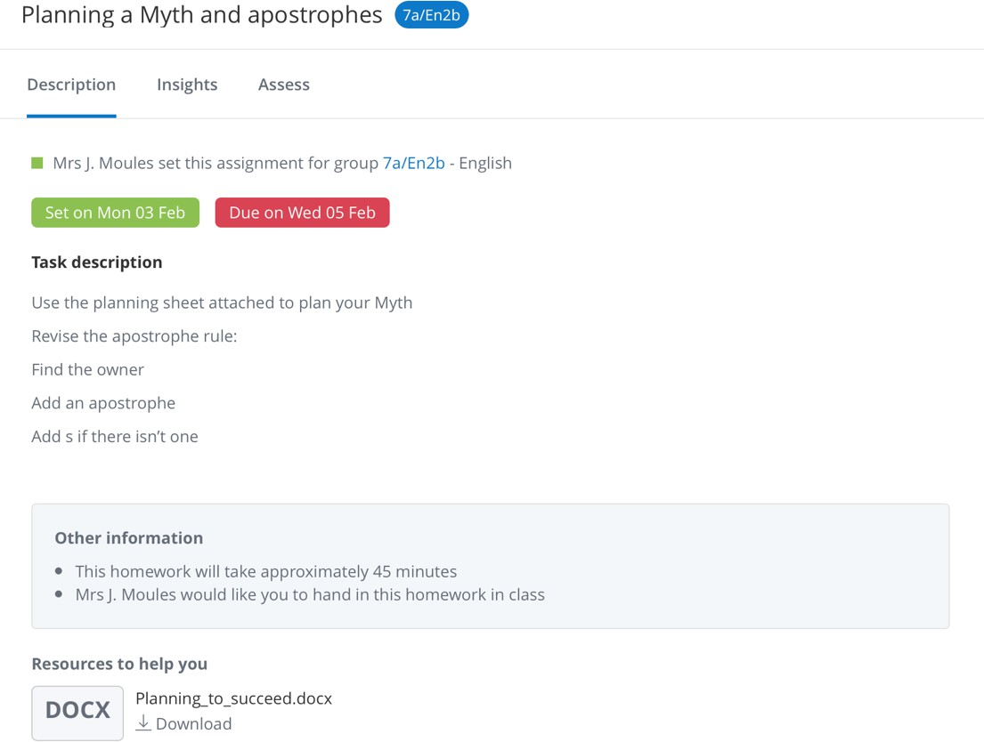

You will be expected to complete your homework and hand it on time.

Personal Development – Leadership, Enrichment, Careers and PSHE

Personal Development is an important part of your time at St Gabriel’s. Our mission statement talks about using our god given talents, embracing diversity and making positive contributions to society. All of these are celebrated in Personal Development. Through getting involved in the wider life of the school you can demonstrate strength, service and success not only during high school but in preparing yourself for life after St Gabriel’s and your future career.

Leadership - We have lots of opportunities for you to develop your leadership skills during your time at secondary school. You will have opportunities to access a Leadership Award in Year 7 and then you are able to apply to be a Leader in an area of school leadership that interests you. Lots of our pupils get involved with these opportunities and leave school with a wide range of excellent leadership skills.

YEAR GROUP | LEADERSHIP OPPORTUNITIES
YEAR 11 | Head Student  Deputy Head Students  Mission and Prayer Leads  Form Representatives
YEAR 10 | Peer Mentors  Hate Crime Ambassadors  Young Interpreters  Subject Ambassadors  Form Representatives
YEAR 9 | Subject Ambassadors  Young Interpreters  Mission and Prayer Leads  Form Representatives
YEAR 8 | Laudato Si Ambassadors  Young Interpreters  Mission and Prayer Leads  Form Representatives
YEAR 7 | Student Leadership Award – ALL YEAR 7  Laudato Si Ambassadors  Young Interpreters  Mission and Prayer Leads  Form Representatives

Enrichment – There at lots of enrichment activities available for you to try at St Gabriel’s. They are a great way to make new friends with similar interests as well as trying something new. We expect in Year 7 to commit to at least one of these. These could be a lunchtime or after school activity. It could be you try a sport or join a team such as netball, rounders, football, basketball or multisport. There are lots of clubs to try too such as STEM chess, coding, drama, choir, photography and lots more. You will receive a timetable of what is on and when once you start in September so make sure you are attending at least one if not lots!

Careers – All subjects link the learning in the classroom to possible careers beyond St Gabriel’s. Through personal development lessons you will learn about the world of work and the skills needed to follow your ideal careers path. You will meet employers and hear about different career paths that could match with your god given talents.

PSHE - Do you know how to keep yourself healthy? How to be respectful to people different from you? Do you know what health relationships look like? During PSHE we will explore all these things and more to make sure you are a valued member of our school community and global society.
Catholic Life and Worship

Every day you will start with a prayer in Form or with your year group in assembly.

There will also be lots of other opportunities to develop your faith. These are just a taster of events you will be involved in in Year 7.

- GIFT Team
- GIFT Team Music Ministry and Choir
- Laudato Si Club
- Cartias Ambassadors
- Mission and Faith Prayer Leaders
- Just Youth Retreat Days
- Chapel Experiences
- Year 7 Welcome Mass
- RE Debate Club
- Remembrance Services
- Advent Christmas Hampers and Cartias St Joseph’s Penny Lenten Appeal

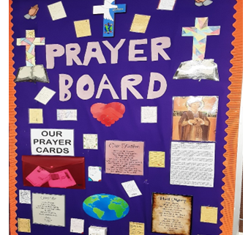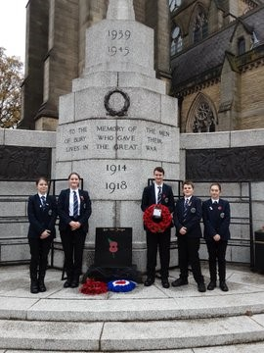

Moving to Your New School and Addressing Any worries

These could be useful to think about when you think about starting school.

Using two different coloured pens, highlight or colour in the phrases that you are looking forward to in one colour; use a different colour for those you are worried about.

Making new friends | Learning a new timetable
Lunch time | Forgetting equipment
Having a different uniform | Being on Time
Finding your way around | Break times
Getting to School | Learning new subjects
Meeting others my own age | Joining new clubs
Being with friends | School rules
Homework | Meeting my form tutor
Meeting my new teachers | Being able to do the work
Being with older pupils | Getting changed for practical activities

Write down anything else that comes to mind.

What are you most excited about?

What are you most worried about?

A Guide to Making New Friends

Below is a list of ideas that may help you in making new friends at St Gabriel’s

- Smile – It’s free and infectious
- Ask questions – Get to know about others
- Join new clubs and activities
- Try something new
- Recognise that we are all different but special in our own way
- Listen and show interest in others
- Treat others as you wish to be treated
- Don’t gossip or make fun of others
- Find out the interests of others – you may share the same

What Are Your Goals/Aims for St Gabriel’s?
When you go to St Gabriel’s, you will learn a huge number of new skills and improve skills you have practiced in Primary School. In the goal below, to write in 10 new skills or things you’d like to build on in your years at Secondary School.



Beyond Secondary School
After secondary school, you can move onto college or an apprenticeship and then to university or into a job! It’s normal not to know what you want to do yet, but this is a chance for you to have a think about your dream jobs!
We have had some famous people come to our school such as Hannah Kelly who achieved a Bronze medal at the Summer Olympics.
Can you find out what she won the Bronze medal for?

You are going to achieve amazing things in your life time.
You will have careers sessions as part of your PSHE programme but here is your opportunity to tell us about your dream job:

Dream Job 1:- | Dream Job 2:-
Key Skills needed:- | Key Skills needed:-
Subjects to Study:- | Subjects to Study:-

Task

Write a letter to your form tutor (I know you have not met them yet) to tell them a little about yourself and your feelings towards starting St Gabriel’s:

Dear Tutor

I will be joining St Gabriel’s High School very soon and I am
feeling because

.

I am looking forward to

However, I am a little nervous as

One thing I would like you to know about me is

Looking forward to meeting you
From
Reading

Reading is a big part of life at St Gabriel’s High School and we encourage all students to read widely for learning and for pleasure. Reading is important for your success at school, your future and most importantly your mental health and well-being. At St Gabriel’s you are provided with many opportunities to develop your reading skills. You will read regularly in form and you will develop subject specific reading skills and vocabulary in all your subjects.

Going to secondary school is a big change, and it’s natural to feel nervous, excited, or just confused. Here are a list of books that tackle the theme of big change. You may want to read some of them before you start at St Gabriel’s or in Year 7.

Fiction

 | When Secrets Set Sail written by Sita Brachmari  A magical and moving adventure story about unlocking stories and secrets of the past
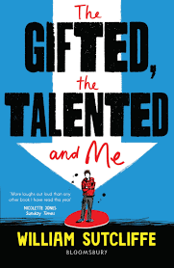 | The Gifted, The Talented and Me written by William Sutcliffe  A brilliantly funny book about fitting in, falling out and staying true to yourself.
 | Artic Star written by Tom Palmer  A gripping story of courage and survival about three young navy recruits on their first mission.

Graphic Novels

 | Frankie’s World written by Aoife Dooley  A two-colour graphic novel offering a unique perspective on Autism, told with humour and heart.
 | Amulet written by Kazu Kibuishi  A world of man-eating demons, a mechanical rabbit, giant robot and two ordinary children on a life or death mission.

Non- Fiction

 | You are Awesome written by Matthew Syed and Toby Triumph  Practical, insightful and positive. This is the book to help you build resilience and embrace your mistakes.
 | You’re a Champion written by Marcus Rashford and Carl Anka  The nations favourite footballer shows how you can achieve your dreams in this positive and inspiring guide for life.

