22nd May 2026

Dear Parent/Carer,

I write to you with reflections drawn from this week’s Gospel and with a gentle exhortation for our community. In John 21:20–22 we read that Peter turned and saw “the disciple following whom Jesus loved, the one who had also reclined upon his chest during the supper and had said, ‘Master, who is the one who will betray you?’” When Peter saw him, he asked Jesus, “Lord, what about him?” Jesus replied, “What if I want him to remain until I come? What concern is it of yours? You follow me.”

Just before this exchange, Jesus had foretold Peter’s martyrdom and concluded by issuing the imperative, “Follow me,” thereby summoning Peter to concentrate upon his personal vocation of discipleship. Peter’s immediate response - curiosity about John’s fate - reveals a human temptation that persists across time: the impulse to fixate upon another’s path rather than to attend faithfully to one’s own calling. Jesus’ reply is measured and instructive; it redirects attention away from unnecessary speculation and back toward the singular responsibility each of us bears.

This passage invites us, as a school community and as families, to consider how easily we can be distracted by comparison or by concern for others’ journeys at the expense of our own commitments. Such curiosity, if unmanaged, can dilute purpose and divert energy from the work before us. The Gospel’s counsel is clear and salutary: we are called to embrace the discipline of our individual mission, to pursue it with steadfastness, and to leave in God’s hands the course of others.

As Headteacher, I encourage us all - staff, student and parent alike - to take this lesson to heart. Let us model focused service for our children, showing them that fidelity to one’s duties and to the moral demands of discipleship is both a practical and spiritual good. In doing so we cultivate a culture in which personal responsibility, character and vocation are prized above idle comparison.

Year 11 - May Half Term Revision

During the Year 11 May half-term, the school will be providing a structured programme of revision sessions to support pupils as they prepare for their GCSE examinations. These sessions will be led by subject specialists and will focus on key content, exam techniques, and targeted areas identified as needing improvement.

Your child can attend in their own clothes and should bring a snack and drink with them.

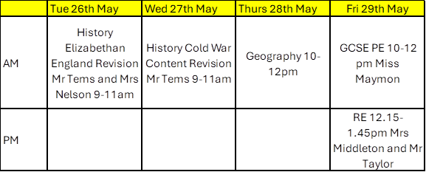

With every assurance of my prayers for your family and our school have a wonderful half term

Yours sincerely

Mr S Braithwaite
Headteacher

