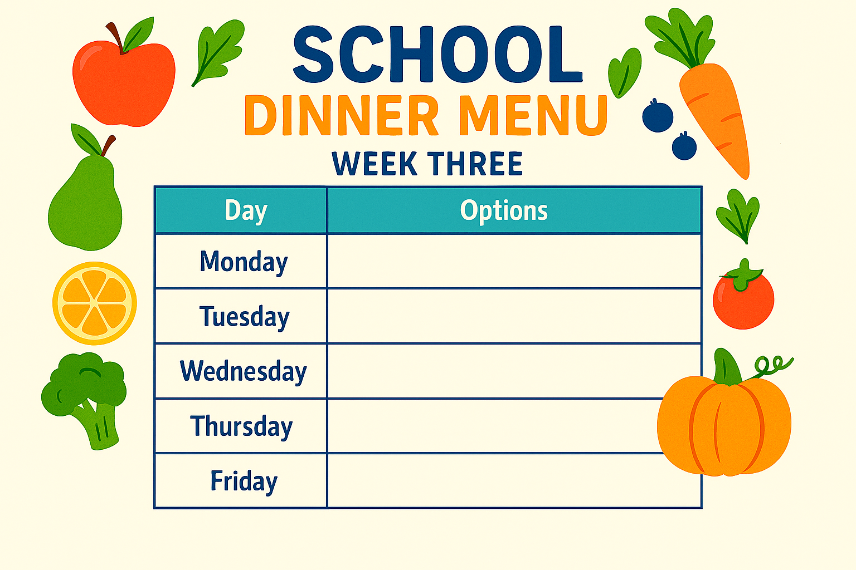
- Fish & Chips
- Pasta Bake
- Tandoori Flatbread
- Cheese Pie & Wedges
- Plant Balls & Pasta
- Chilli & Rice
- Piri Piri Chicken Breast & Wedges
- Chicken & Noodles
- Pizza
- Toad In The Hole With Mash & Veg
- Veg Toad In The Hole With Mash & Veg
- Chicken Burger
- Chicken Korma & Rice
- Mac & Cheese
- Chicken Fajita Wrap

