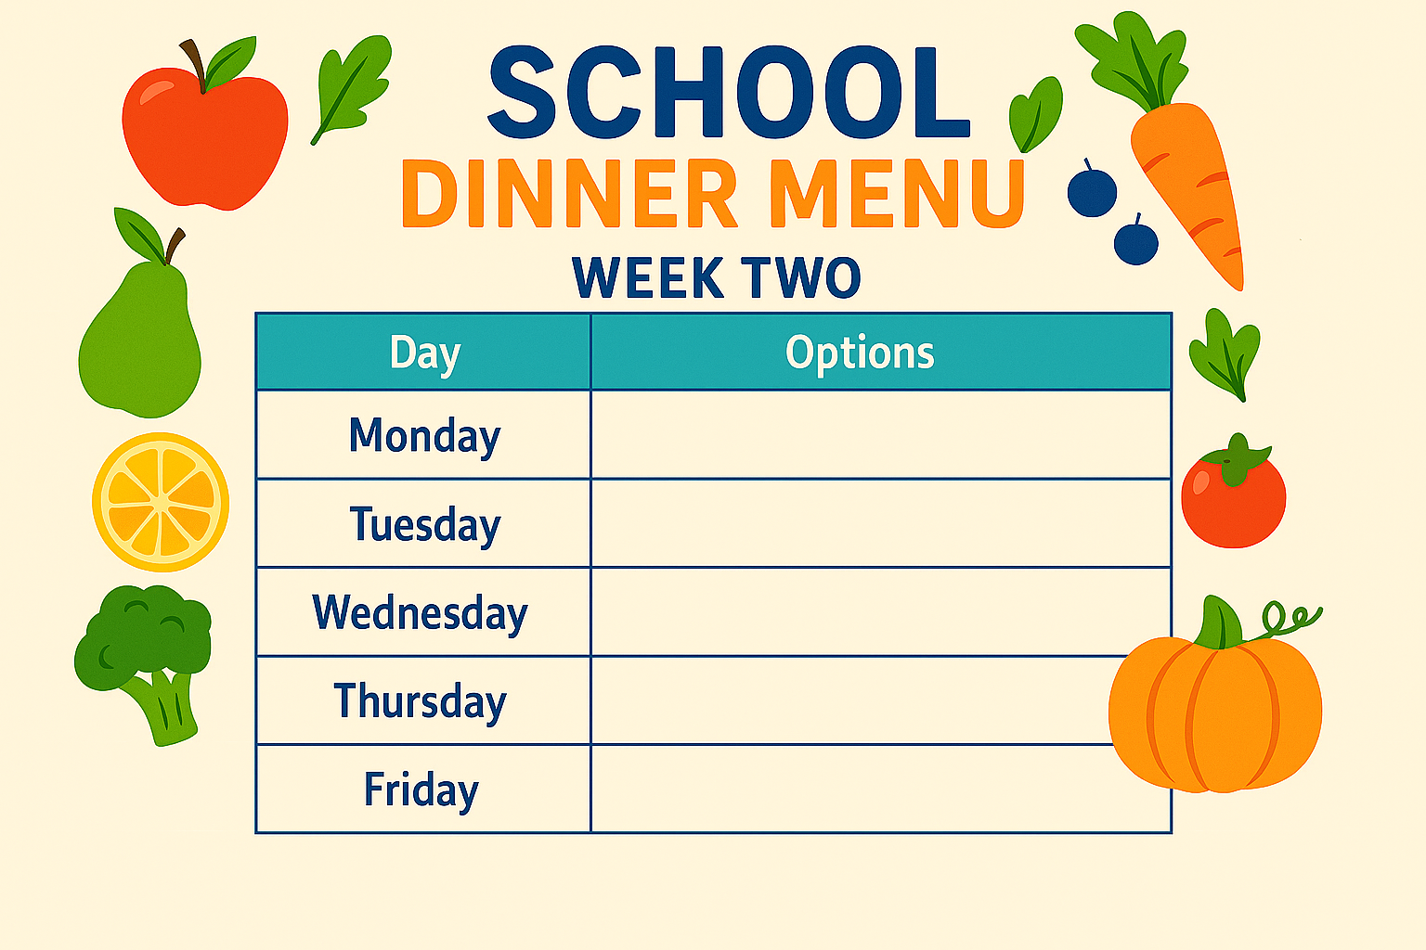
- Pasta Bolognese
- Chicken Goujons
- Vegetable Bake
- Fish & Chips
- Bean Burger & Chips
- Quiche & Chips
- Chinese Chicken Curry & Rice
- Nachos
- BBQ Chicken Drumsticks & Wedges
- Meat Pie With Mash & Veg
- Pizza
- Chicken & Noodles

- Chicken tikka & Rice
- Pasta & Sauce
- Cottage Pie

