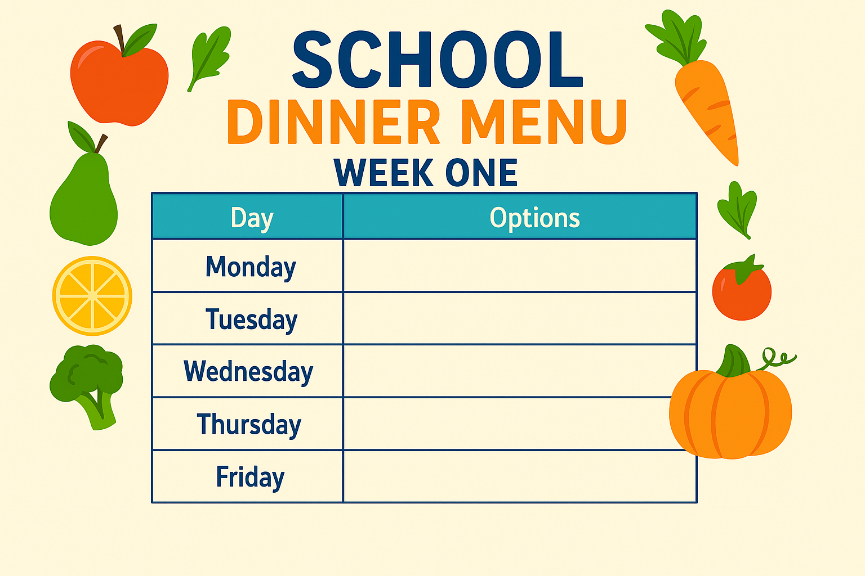
- Fish & Chips
- Mac & Cheese
- Panini
- Chicken Katsu Curry & Rice
- Chilli Non Carne & Rice
- Pizza
- Lasagne
- Chicken Wrap
- Fish Burger
- Buffalo Chicken & Wedges
- Quorn Nuggets & Savory Rice
- Sausage Baguette
- Nachos
- Meatballs & Pasta
- Fish Finger Wrap
- Pasta & Sauce

