20th March 2026
Dear Parents and Carers,
I hope this letter finds you well. This week, our celebration of the word invited us to deeply consider a powerful quotation from Dr Seuss: “Why fit in when you were born to stand out?” This message challenges us to recognise and celebrate the unique qualities that each student brings to our school community. At St Gabriel’s, we strive to create an environment where individuality is not only accepted but encouraged, enabling every student to flourish by embracing their distinct talents, perspectives, and passions. This ethos is reflected in our diverse curriculum and extracurricular opportunities, which empower students to develop confidence and resilience as they stand out in their own positive ways.
Alongside this, we reflected on the passage from the Gospel of Matthew 7:1-5, often called The Parable of the Speck and the Log. This scripture reminds us of the importance of humility and self-awareness: “Do not judge, or you too will be judged... For in the same way you judge others, you will be judged.” This teaching is especially relevant in school life, where students encounter a wide range of backgrounds and experiences. It encourages our community to foster empathy, kindness, and understanding, promoting a culture where differences are respected rather than criticised. By looking inward and recognising our own imperfections, we create a safer, more supportive environment where everyone feels valued and accepted.
As part of our inclusive community, we would also like to extend our warmest wishes to our Muslim students and their families as they celebrate Eid. We wish you a very happy and blessed Eid filled with joy, reflection, and togetherness.
The word of the Lord.
Response: Thanks be to God.
Lord, whenever we feel tempted to judge another’s actions because they are different than us, help us to check our motives and guard our speech. Give us discernment and wisdom when dealing with difficult situations. We never want to cause harm or make someone upset.
Amen.
May these reflections inspire both our students and the wider school community to act with compassion, integrity, and the courage to stand apart in ways that enrich us all.
Theatre trip
This week, 22 of our Y10 and 11 GCSE Performing Arts students watched The Woman in Black at the Alhambra Theatre, Bradford. The play, based on the 1983 gothic Horror novel of the same name by Susan Hill, tells the story of an obsessed lawyer who engages a young actor to help him dramatize a terrifying story about a vengeful ghost that has haunted him for years. Together, they recreate his experiences at an isolated and haunted house, uncovering a dark secret and unleashing a sinister presence that breaks the barrier between the past and present. Our students really enjoyed the superb production, performed by a just a two-person cast, and thankfully were able to endure the many jump scares throughout.
Lent Charity Appeal: Cartias St Joseph's Penny
In the final two weeks of term, we need a final push on our fundraising efforts for St Joseph's Penny. An enormous thank you to all of the forms who have been running fundraising activities so far, and we look forward to more in the run-up to the Easter holidays.
Please be aware that the Mission Rewards Trip Day (Friday 27th March) will be a non-uniform day for all and students should bring in a donation for Cartias St Josephs Penny or donate via the link below:
https://gofund.me/f8e9b070b
Year 11
Year 11’s parents evening is on Thursday 26th March 2026 from 3.45 – 6:45pm.
Please encourage your Year 11 child to attend the After School Tuition sessions. Year 11 Students should be spending at least 1-2 hours on revision a night leading up to the Public Exams in order to consolidate their learning.

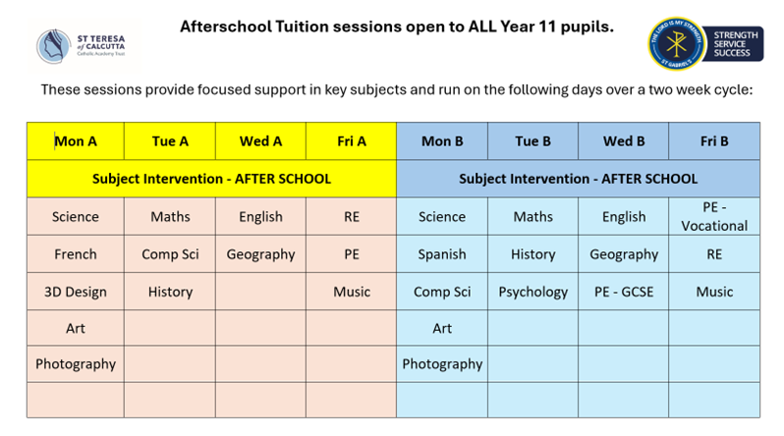

Yours sincerely,

Mr S Braithwaite
Headteacher

