13th March 2026
Dear Parents and Carers,
In this week’s reflection, I wish to draw your attention to a profound teaching from the Gospel of Luke, specifically the parable of the Pharisee and the tax collector who went up to the temple area to pray (Luke 18:9–10). Jesus directed this parable to those who were convinced of their own righteousness and looked down upon others, offering a timeless lesson on the nature of true holiness and the virtue of humility.
Humility, indeed, is a beautiful and transformative virtue. Even the most publicly flawed sinner, exemplified by the tax collector, radiates with God’s grace when his heart is purified by genuine humility. In stark contrast, pride is an insidious and repellent vice; its presence renders the soul incapable of reflecting the pure and luminous light of God. The parable teaches us that true sanctity is not a matter of outward appearances or self-righteous proclamations, but rather an interior state where the virtues of the soul allow God’s radiance to shine forth.
We inevitably encounter individuals whose lives seem to glow with God’s grace, peace, and joy, while others may emanate judgement, self-righteousness, and condemnation. Although it is not our place to judge, we cannot help but be inspired by the authentic humility embodied in those marked by grace. Consider, for instance, the enduring legacy of Saint Mother Teresa: while many may not recall the precise words of her speeches, the radiant charity she exemplified, born out of profound humility, leaves an indelible impression on all who encounter her story.
Lent Charity Appeal: Cartias St Joseph's Penny
Please be aware that the Mission Rewards Trip Day (Friday 27th March) will be a non-uniform day and students should bring in a donation for Cartias St Josephs Penny or donate via the link below
https://gofund.me/f8e9b070b
Year 11
Please encourage your Year 11 child to attend the After School Tuition sessions. Year 11 Students should be spending at least 1-2 hours on revision a night leading up to the Public Exams in order to consolidate their learning.

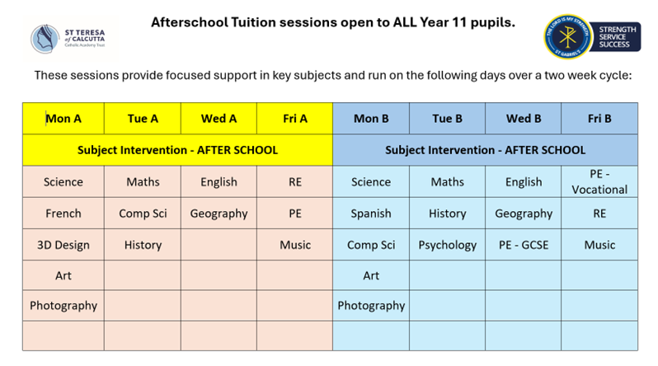
A reminder that year 11 will have their final school photograph taken on Friday 20th March.

Yours sincerely

Mr S Braithwaite
Headteacher

