**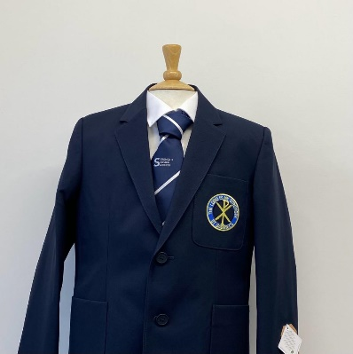PTS School Wear Ltd**

**14 Market Parade 7 New Road**

**Bury Radcliffe**

**Lancashire Manchester**

**BL9 0QE M26 1LS**

**0161 761 1365 0161 723 0991**

[**www.pts-schoolwear.co.uk**](http://www.pts-schoolwear.co.uk)

***Spend & save in June & July Only***

**St Gabriel’s High School Uniform List 2025**

Prices are correct at the time of printing.

**(Yr.7 Sky Yr.8 Purple Yr.9 Silver Yr.10 Gold Yr.11 Red)**

**Girls**

**From**

**Badged Blazer** 39.99

**Navy Badged Pinafore** 23.99

**Trousers Black** 20.50

**Blouses White Twin pack** 18.99

(Button neck worn With Tie)

**School Tie** 8.50

**Navy Jumper with logo** 21.99

**White Apron** 9.50

**Cream Apron** 9.50

**Name Tapes** 3.50

**Boys**

**From**

**Badged Blazer** 39.99

**Trousers Black** 16.99

**Shirts Twin pack** 18.99

**School Tie** 8.50

**Navy Jumper with logo** 21.99

**White Apron** 9.50

**Cream Apron** 9.50

**Name Tapes** 3.50

**P.E Kit**

**Badged P.E Top**  18.99

**Shorts**  11.50

**Gym Skort**  16.99

**Navy Football Socks** 7.99

**Badged Hoody** Opt 25.99

**Training Trousers** Opt20.50

**School Leggings** Opt17.99

**SPEND & SAVE**

**£3.00 OFF**

When you spend £30

**£5.00 OFF**

When you spend £50

**£10 OFF**

When you spend £100