**St Gabriel’s Home Learning Agreement 2024-2025**

**Rationale for this agreement:**

Research carried out by the EEF on homework in secondary schools evidences…

“…the impact of homework, on average, is **five months' additional progress**. However, beneath this average there is a wide variation in potential impact, suggesting that **how homework is set is likely to be very important**… Homework has been extensively researched. There is a relatively consistent picture that **pupils in schools which give more homework perform better**… Some studies indicate that there may be an optimum amount of homework of between **one and two hours per school day (slightly longer for older pupils)**, with effects diminishing as the time that students spend on homework increases.”

The setting of homework in secondary schools is shown to be one of the **most impactful methods of teaching and learning** when implemented to a high standard.

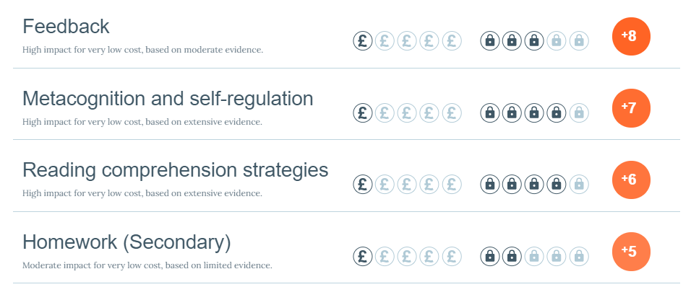

**Home Learning:**

Our St Gabriel’s Mission Statement states that we ‘strive to use our God-given talents to **serve** others and to **succeed’.** Therefore, to be successful in their education, students need to complete home learning activities. It is an expectation that as students' progress through the school home learning activities are age appropriate and more challenging. This is reflected in the time increasing amount that students are required to spend on home learning through their five years at St Gabriel’s. It is anticipated that students in Key Stage 3 should spend up to four hours a week, rising to five hours in Year 10 and 11. This is in line with British national averages.

**KS3**

Students are to receive weekly home learning in English, Maths, Science, RE, MFL, Humanities and two home learning tasks per rotation for subjects such as Art, Drama, Music, Design and Technology and Computer Science. PE will set one home learning task per unit of work. The students should be given a week to complete any weekly home learning activities.

**KS4**

Students are to receive weekly home learning in all their GCSE subjects. The students should be given a week to complete the home learning activities.

**Inclusion:**

As with classwork, home learning may be adapted for students to ensure all can access/complete the tasks and all are suitably challenged. Instructions must be very clear and unambiguous.

One recommended strategy for adapted home learning is to provide support information as we do in class. For example, scaffolds, or top tips, so that the tasks are accessible for all. Challenge tasks should be designed to stretch more able students.

Teachers should pre-empt barriers to students completing home learning and ensure strategies are implemented to remove these. For example, if the home learning requires access to a virtual learning platform, a printed version / alternative task will need to be made available for students without access to IT at home.

**Agreed Home Learning Tasks:**

Teachers are expected to set a range of home learning tasks to give students a varied and engaging independent learning experience. Home learning should not always take the form of online learning or always require students to complete examination questions.

It is important that tasks are an extension of or a development of the curriculum which provides students with the opportunity to pre learn, over learn, and practice application.

The following tasks have been agreed as suitable for home learning:

* GCSE Pod: Watch/listen to podcasts and complete accompanying activities (e.g. quizzes).
* Activities on Sparx/Language Nut/Seneca Learning / Focus on Sound.
* Assignments, quizzes and spelling tests on Show My Homework.
* Topic projects with mini-deadlines to support students in managing their time.
* Creation of revision materials (e.g. flash cards) and knowledge organisers.
* Use of revision guides; reading and activities.
* Prescribed reading with follow-up tasks (e.g. comprehension, preparation for class discussion/debate).
* Spelling tests in all subjects for every topic (revision for home learning).
* Unit review preparation tasks.
* Long-term retrieval tasks.
* Examination style questions
* Extended writing opportunities in a variety of genres (e.g. letters, poetry, persuasive writing, emotive writing).
* Interviewing people at home as part of research into a topic.
* Researching topics using pre-determined information sources (e.g. articles and web links).
* Practicing practical skills (e.g. cooking, musical performance, composition, skills linked to P.E. and drama)
* Completing listening exercises (e.g. Music, French and Spanish).
* Preparation for solo or group presentations and performances.
* Competition entries (school-based competitions or national/international competitions).

**Setting Home Learning:**

We must consider setting home learning when lesson planning. Time should be given to discuss the requirements of the tasks. Students should have the opportunity to ask questions and seek clarity.

Please be mindful that setting home learning at the end of the lesson can lead this to be rushed, and may suggest that it is less important than the classwork tasks. It is preferable for home learning to be set after the *Do Now* task, or after the *Progress Check* for these reasons.

**Assessment Expectations:**

Teachers must consider **how and when** home learning will be assessed in advance of setting work. The teacher **must** check that all students have submitted the home learning on time to the expected standard to issue rewards and sanctions accordingly.

The following assessment methods may be used:

* Teacher assessment
* Peer assessment
* Self assessment
* Presentation
* Discussion
* Computer assessment

**Home Learning Related Rewards / Sanctions:**

* Mission points for ‘success’ will be given to students who submit home learning tasks on time to the expected high standard at the time of teachers checking the work. Excellent home learning mission point may be given for outstanding pieces of work.
* Teachers will input in Arbor the QoE sanction code ‘S3 or an S2’ when home learning is either not submitted or not completed to the expected standard (unless a note from a parent/carer is produced to provide an explanation). Students will only be given one opportunity to submit home learning; teachers will not chase it. It will not be acceptable for students to bring it in the following day or next lesson.

**Support:**

The Resource Centre is open from 8.00am until the school day starts, break time, lunch time and after school until 4.00pm for students to have a quiet space to complete their home learning.

A home learning club is available from 3.10-3.40pm for students with SEND in each year group one day per week with the Freeman Learning Hub. Departments may also offer home learning clubs on their designated extra-curricular evening each week subject to staffing.

Both Key Stage 3 and Key Stage 4 have online learning hubs where additional resources are available.

**Communication:**

Relevant details of this home learning agreement will be shared with all students, parents/carers and staff in September 2024. An overview will also be available on our school website.

Home learning resources and tasks will be shared with students and parents/carers via Satchel One.

**Monitoring:**

The monitoring of home learning will be conducted by Curriculum Leaders as part of Quality Assurance.

**July 2024**