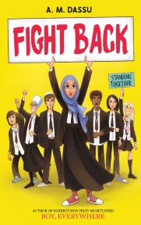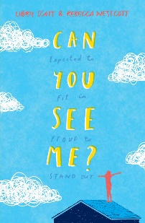**Year 7 recommended reading list for children aged 11-12**

* 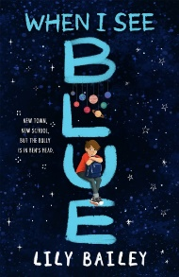Fight Back by A. M. Dassu
* 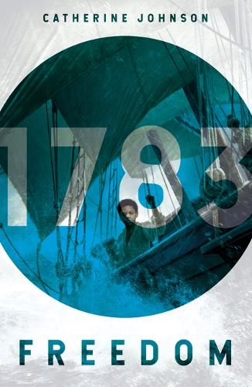Can You See Me? By Libby Scott and Rebecca Westcott
* When I See Blue by Lily Bailey
* Freedom (1783) by Catherine Johnson
* Artichoke Hearts by Sita Brahmachari
* Kick by Mitch Johnson
* Watership Down by Richard Adams
* The Goldfish Boy by Lisa Thompson
* 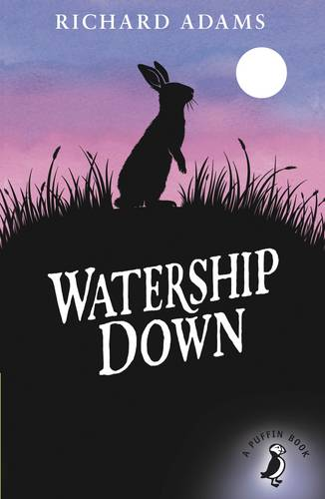The Island at the End of Everything by Kiran Millwood Hargrave
* 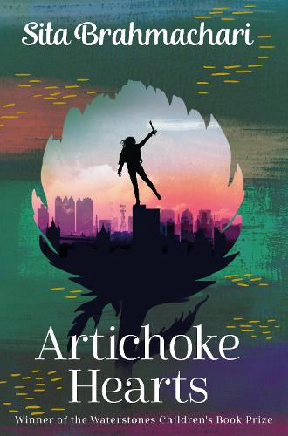The Wolves of Wiloughby Chase by Joan Aiken
* 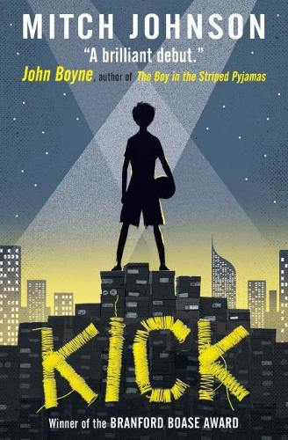Robin Hood: Jet Skis, Swamps and Smugglers by Robert Muchamore
* Peter Pan by J.M Barrie
* The Dark is Rising by Susan Cooper
* Wolf by Gillian Cross

