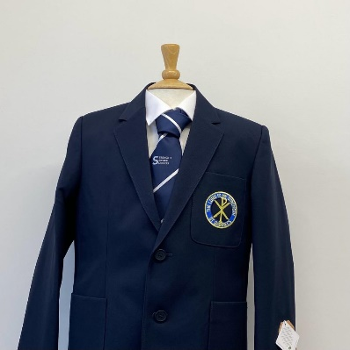**PTS School Wear Ltd**

Savings Club

School Vouchers

Accepted

**14 Market Parade 7 New Road**

**Bury Radcliffe**

**Lancashire Manchester**

**BL9 0QE M26 1LS**

**0161 761 1365 0161 723 0991**

[**www.pts-schoolwear.co.uk**](http://www.pts-schoolwear.co.uk)

***Sale on Selected Garments in June & July Only***

**St Gabriel’s High School Uniform List 2023**

Prices are correct at the time of printing.

**(Yr.7 Silver Yr.8 Gold Yr.9 Red Yr.10 Sky Yr.11 Purple)**

**Girls**

**From Special Offer**

**Badged Blazer** 37.99 34.19

**Navy Badged Pinafore** 23.99

**Trousers Black** 16.99

**Blouses White Twin pack** 16.99

(Button neck worn With Tie)

**School Tie** 7.99

**Navy Jumper with logo** 21.99

**White Apron** 8.99

**Cream Apron** 8.99

**Name Tapes** 3.50

**P.E Kit**

**Badged P.E Top**  18.99 17.99

**Gym Skort**  16.99

**Badged Hoody** Opt 25.99 23.39

**School Leggings** Opt17.50 15.75

**Navy Sports Socks** 7.99

**Boys**

**From Special Offer**

**Badged Blazer** 37.99 34.19

**Trousers Black** 16.99

**Shirts Twin pack** 16.99

**School Tie** 7.99

**Navy Jumper with logo** 21.99

**White Apron** 8.99

**Cream Apron** 8.99

**Name Tapes** 3.50

**P.E Kit**

**Badged P.E Top**  19.99 17.99

**Shorts**  10.99

**Navy Football Socks** 7.99

**Badged Hoody** Opt 25.99 23.39

**Training Trousers** Opt19.99 17.99

**Navy Sports Socks** 7.99