[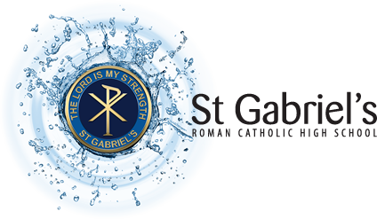](http://www.st-gabriels.org.uk/)St Gabriel’s

Roman Catholic High School

Dear all,

As you are aware Year 11 parents’ evening was unfortunately postponed.

Please use the links below to find out more about our various subjects and what you need to know about helping your child prepare for mock examinations.

PE <https://youtu.be/qqIAw8GwgVE>

Music <https://youtu.be/8JYe6cUdcU4>

MFL <https://youtu.be/w8lIg6kKffU>

Media Studies <https://youtu.be/JVa3mtc8wyk>

Maths <https://youtu.be/GyUbN1yD1xs>

iMedia <https://youtu.be/b5Z0P9NZ7jE>

History <https://youtu.be/Ny-mO1Wvibg>

Geography <https://youtu.be/OvVeAtjP6A0>

Food <https://youtu.be/pY5FVa3469s>

English <https://youtu.be/dMazOahPzlA>

Drama <https://youtu.be/u3bwXydWHOg>

D & T <https://youtu.be/acmltpMiC84>

Computer Science <https://youtu.be/qWc2psNccg4>

Science <https://youtu.be/l_78MpkCiiQ>

Art <https://youtu.be/tLu93LV626s>

We hope you find these helpful.

Good luck to all our year 11s.

With thanks.