Dear Parents and Carers,

Thank you for all your ongoing support this half term. We have fared better regarding Covid absences than we anticipated!

In the next half term, our Year 11s start their final round of GCSE mock examinations. **We would urge all parents and carers of Year 11 students to ensure they prepare fully for their mocks**. This is the final chance for staff to identify gaps in our students’ knowledge and re-teach any misconceptions. Some students seem to feel that because the Government have said that boundary grades will be more lenient, there is no real concern this year. However, this is far from true. We need all our Year 11s to be working as hard as their teachers to tackle any gaps left due to Covid absences. **Mocks start on 28 Feb** – one week after our return.

Many students have been given revision resources from staff and booklets, for example, from Science containing information and QR code links to revision materials. **The topics on the exams were only released days ago, so please ensure your child is using the correct topics to revise from.**

In the last half term, poor punctuality has started to raise its head again. Now that we have the new fence around the John Banks building, with electronic locking gates, the gates will be locked approximately 5 minutes after the lesson starts and finishes for safeguarding purposes. Students who are seen to be late to the John Banks without fast walking will be issued with an after school detention. Please support us with this consequence, as students are missing valuable learning time. No student who has a note from another teacher or who is seen fast walking to lesson will receive any consequence at all, but those late to lesson who can be seen not making an effort to get there before the gates lock, will be issued with a detention.

**Good news on the catering front!**

After a successful meeting with our catering company, the food offer has been re-evaluated. Hot puddings will now be available every day – like the good old school days with sponge pudding and custard! The main course options have also been re-evaluated to include the options on the next page. Please see new menus attached to this email.

This week, all our assemblies have been led by the Head, focused on our service to our community by praying for those who may be ill, or those who have suffered losses. We place our prayers to our Blessed Lord and St Raphael for all our St Gabriel’s family and **received over 600 prayer cards from students wishing us to pray for family members.**

***Dear God, we place our worries in your hands. We place our sick under your care. Grant us the grace to acknowledge your will and know that whatever you do, you do for the love of us. Amen.***

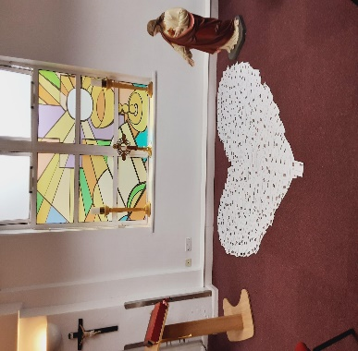

Your St Gabriels Team